Purchase Quarterly Meeting
August 3, 2008
Croton Valley Meeting, 210 Meetinghouse Road, Mt. Kisco, NY

Gathering 10:30 AM
Worship 11:00 AM
Brown-bag lunch 12:30 PM (beverages and desserts provided by Amawalk Friends)
Purchase Quarterly Meeting for Business will begin about 1:15 PM

Please note: there are no food shops near the meeting house, so Friends should plan to pack their brown bag prior to arrival

A nature program will be offered for children ages 3 and older from 10:45 AM to 12:15 PM
(No childcare for children under three years will be available.)
Participants should wear shoes and clothing for outdoor activity, rain or shine!
KINDLY PRE-REGISTER CHILDREN before JULY 27 by calling 914-232-5480

CAR POOLING IS URGED, as parking is very limited
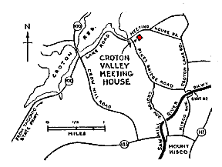
From Sawmill River Parkway : Take Kisco Avenue Exit 37. Turn right at foot of ramp and go 0.1 mile to fork. Turn left on Pine Bridge Road and go 1.7 miles to Lake Road. Turn right and meeting house is 0.1 mile on the right.
From Taconic State Parkway : Take Route 100 (Millwood) exit. Turn right at foot of ramp and follow Route 100 for 4.0 miles to Crow Hill Road. Turn right and immediately left onto Lake Road and go 1.5 miles. After crossing a small bridge, keep straight ahead instead of turning right, as indicated by the direction sign. The meeting house is 0.1 mile on the right.
For additional information contact Polly Goodwin at 914-232-5480 or pollygoodwin@verizon.net

